  - STAT 4360, Fall 2024
  - Benny Frisella

Mini Project IV
Section 1
Using the wine dataset,

- a) A linear model with Quality as the response and using all predictors(with a factored Region) gave a Mean Squared Error(MSE):
b) c) d) g) Figure 1 below shows results from best subset selection:

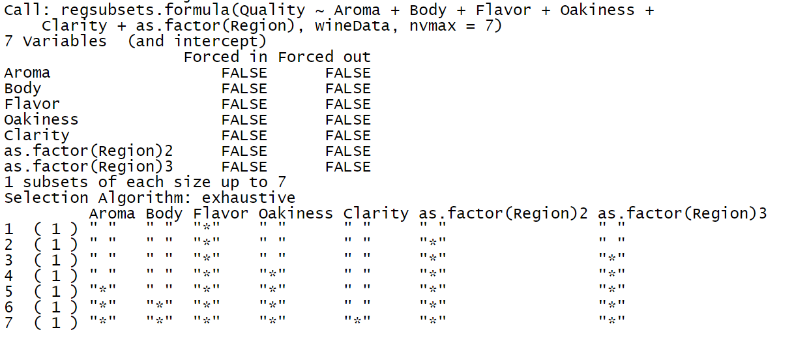
Figure 1
The best(maximum) adjusted R² model gave the model at index 4 from Figure 1, which is:

Figure 2

Surprisingly, the best forward selection and backward selection models were found to be of the exact same model as best subset selection.

They were all chosen by the best adjusted R² and I believe the 3 selection methods came to the same conclusion because there are only 6 predictors; R will use 2 dummy variables for the factored 3 Regions, so the true number of predictors I used was 7, but that still isn’t many – especially for a dataset of 38 rows. The results are shown in Figure 3 below. It shows the equal adjusted R² values along with the same coefficients for each.
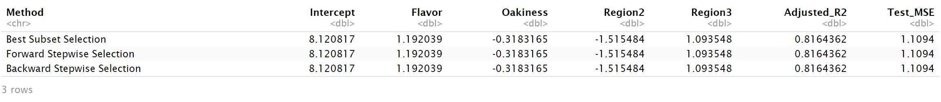
Figure 3

The test MSE was found using Leave-One-Out-Cross-Validation(LOOCV) which resulted in a test MSE of 1.1094. Since the selections all chose the same model, the test MSEs using LOOCV are all identical. Therefore, I can only recommend the model in Figure 2 for prediction based on the 3 selection methods as it had a lower MSE than the first simple linear model using all predictors.

e) Using Ridge Regression, the penalty parameter was chosen optimally using LOOCV and found to be 0.3162278; and the test MSE using that penalty parameter was 0.7004688.

f) Using Lasso, with the penalty parameter also chosen optimally using LOOCV, the penalty parameter was found to be 0.1293366; and the test MSE using that penalty parameter was 0.7154189.

Overall, I would recommend Ridge Regression or Lasso here with a preference for Lasso. Although Ridge Regression resulted in the lowest test MSE, Lasso offers a nearly equivalent test MSE with less than half of the penalty. Thus, Lasso balances flexibility and good predictive performance better than the rest for this dataset.

- Rewrite to:
min_{β}​[0.5(Y − Xβ)^{T} (Y − Xβ) + (λ / 2) ​β^{T}β]

Differentiate with respect to β and set equal to zero:
−X^{T}(Y − Xβ) + λβ = 0
Rearrange:
X^{T}Y = X^{T}Xβ + λβ
Factor:
(X^{T}X+λI)β = X^{T}Y
With I being the Identity matrix:
Β^{hat} = (X^{T}X + λI)⁻¹ X^{T}Y

- Assuming errors are i.i.d.
Y_{i​} = f(X_{i​})+ϵ_{i}
For i != j:
Cov(Y_{i​,}Y_{j}​) = Cov(f(X_{i}​) + ϵ_{i}​,f(X_{j}​) + ϵ_{j}​)

Since errors are independent:
Cov(Y_{i}​,Y_{j}​) = Cov(f(X_{i}​), f(X_{j}​)) + Cov(ϵ_{i}​,ϵ_{j}​)

Since e_{i}, e_{j} are independent, Cov(e_{i}, e_{j}) = 0:
Cov(Y_{i}​, Y_{j}​) = Cov(f(X_{i}​), f(X_{j}​))

Y^{hat}_{i} = X_{i}^{T​}β^{hat}
Substituting β^{hat} from a)
Y^{hat}_{i}​ ​= X_{i}^{T} (X^{T}X + λI)⁻¹ X^{T}Y

The fitted value Y^{hat}_{i}​ is a linear combination of actual values Y_{j:}
Y^{hat}_{i}​ =∑_{i = 1 to n}​w_{ij​}Y_{j​}
Therefore:
Cov(Y^{hat}_{i}​ Y_{i}​) = Cov(∑_{from j = 1 to n}​w_{ij}Y_{j​,}Y_{i}​) = w_{ij} Cov(Y_{j}​, Y_{i}​)

Since Cov(Y_{j}​, Y_{i}​) = Var(Y_{i}​) and Cov(Y_{j}​, Y_{i}​) = Cov(f(X_{j}​), f(X_{i}​)) for j != i then:

∑_{from 1 to n} Cov(Y^{hat}_{i}​ Y_{i}​) = ∑_{from 1 to n} ​[∑_{from 1 to n} ​ w_{ij} Cov(Y_{j}​, Y_{i}​)]

Section 2 R code
---
title: "Mini Project 4"
author: "Benny Frisella"
date: "2024-11-03"
output: pdf_document
---

```{r setup, include=FALSE}
knitr::opts_chunk$set(echo = TRUE)
```
##1.
```{r}
wineData <- read.csv("wineData.txt", header = TRUE, sep = '\t')
```

(a) Fit a linear regression model using all predictors and compute its test MSE.
```{r}

library(boot)

#########1. (a)
#use LOOCV for all test MSE #
#take Quality as response with other 6 as predictors
wine_lm <- lm(Quality ~ Aroma + Body + Flavor + Oakiness + as.factor(Region) + Clarity, data = wineData)

#perform LOOCV to compute test MSE using k folds where k = n
glm.fit <- glm(wine_lm, data = wineData)

cv.err <- cv.glm(wineData, glm.fit)

cat("Simple linear model LOOCV MSE (bias_adjusted):", cv.err$delta[1], '\n')

#Check higher polynomial models for better MSE#
#try for Flavor
cv.err_poly <- sapply(1:5, function(degree)
{
fit <- glm(Quality ~ poly(Flavor, degree) + Body + Aroma
+ Oakiness + as.factor(Region) + Clarity, data = wineData)

#LOOCV, extract bias_adjusted MSE
cv.glm(wineData, fit)$delta[1]
})

#cv.err_poly
#Note: A cubic model featuring Flavor^3 yields the lowest MSE: 1.084790, this degree may be best fit for the data.

```
(b) Use best subset selection based on adjusted R-squared
to find the best linear regression model. Compute
the test MSE of the best model.

```{r}
library(leaps)

##########1. (b)

#fit full model, 7 predictors because R adds 2 dummy variables for as.factor(Region)
fit.full <- regsubsets(Quality ~ Aroma + Body
+ Flavor + Oakiness + Clarity
+ as.factor(Region), wineData, nvmax = 7)
print(fit.full)

#gives the best model for each size
fit.summary <- summary(fit.full)

#get index of the model with the highest adjusted R-squared
best.model.index <- which.max(fit.summary$adjr2)

#display the summary of fits
print(fit.summary)

#plot adjusted R-squared
plot(fit.summary$adjr2,
xlab = "Number of Variables",
ylab = "Adjusted R-squared",
type = "l")

points(best.model.index, fit.summary$adjr2[best.model.index],
col = "red", cex = 2, pch = 20)

#gave model 4
```

```{r}
#try model with 2 predictors + 2 as.factor() predictors for region 2,3:
#subset the data to include only Region levels 2 and 3
wine_region_subset <- subset(wineData, Region %in% c(2, 3))

#fit the model using the subset data
wine_lm2 <- lm(Quality ~ Flavor + Oakiness + as.factor(Region), data = wine_region_subset)

#fit generalized linear model
glm_fit2 <- glm(wine_lm2)

#use LOOCV to compute test MSE
cv_err2 <- cv.glm(wine_region_subset, glm_fit2)

#LOOCV MSE
cat("Model MSE (bias_adjusted) using Region levels 2 and 3,
Flavor and Oakiness by best subset selection:", cv_err2$delta[1], '\n')

```
Use forward stepwise selection based on adjusted R-squared
to find the best linear regression model.
Compute the test MSE of the best model.
```{r}
#######1. (c)
fit.fwd <- regsubsets(Quality ~ Clarity + Body + Aroma + Flavor + Oakiness
+ as.factor(Region),
data = wineData, nvmax = 7, method = "forward")

#Best forward stepwise selection#

#gives the best model for each size
fit.summary2 <- summary(fit.fwd)

print(fit.summary2)

#get index of the model with the highest adjusted R-squared
best.model.index2 <- which.max(fit.summary2$adjr2)

#plot adjusted R-squared
plot(fit.summary2$adjr2,
xlab = "Number of Variables",
ylab = "Adjusted R-squared",
type = "l")

points(best.model.index2, fit.summary2$adjr2[best.model.index2],
col = "blue", cex = 2, pch = 20)

```

```{r}
#######1. (d)
fit.bwd <- regsubsets(Quality ~ Clarity + Body + Aroma + Flavor + Oakiness
+ as.factor(Region),
data = wineData, nvmax = 7, method = "backward")

# Best backward stepwise selection #

#gives the best model for each size
fit.summary3 <- summary(fit.bwd)

print(fit.summary3)

#get index of the model with the highest adjusted R-squared
best.model.index3 <- which.max(fit.summary3$adjr2)

#plot adjusted R-squared
plot(fit.summary3$adjr2,
xlab = "Number of Variables",
ylab = "Adjusted R-squared",
type = "l")

points(best.model.index2, fit.summary3$adjr2[best.model.index3],
col = "green", cex = 2, pch = 20)

```

(e) Use ridge regression with penalty parameter chosen optimally
via LOOCV to fit a linear regression model. Compute the test MSE of the model.

```{r}
######1. (e)
library(glmnet)

# Prep #
x <- model.matrix(Quality ~ Clarity + Body + Aroma + Flavor + Oakiness + as.factor(Region), data = wineData)[,-1]
y <- wineData$Quality

#compute MSE
mse <- function(actual, predicted)
{
mean((actual - predicted) ^ 2)
}

#LOOCV to find the optimal lambda
#set.seed(8)
n <- nrow(wineData)
lambda_seq <- 10^seq(3, -3, by = -0.1) #sequence of lambda values
mse_values <- numeric(length(lambda_seq)) #store MSE for each lambda

for (i in 1:n)
{
train_indices <- -i
test_indices <- i

x_train <- x[train_indices, ]
y_train <- y[train_indices]
x_test <- x[test_indices, , drop = FALSE]
y_test <- y[test_indices]

ridge_model <- glmnet(x_train, y_train, alpha = 0, lambda = lambda_seq)

#predict using the fitted model
preds <- predict(ridge_model, s = lambda_seq, newx = x_test)

#calculate MSE for each lambda
mse_values <- mse_values + colMeans((preds - y_test) ^ 2)
}

#average MSE across all n from LOOCV
mse_values <- mse_values / n

#optimal lambda
optimal_lambda <- lambda_seq[which.min(mse_values)]
cat("Optimal Lambda:", optimal_lambda, "\n")

#fit the final ridge regression model with the optimal lambda
final_ridge_model <- glmnet(x, y, alpha = 0, lambda = optimal_lambda)

#predict on the full data to calculate final MSE
final_preds <- predict(final_ridge_model, s = optimal_lambda, newx = x)
final_test_mse <- mse(y, final_preds)

cat("Test MSE of the ridge regression model:", final_test_mse, "\n")

```

```{r}
#set up a function to compute the MSE
mse <- function(lambda)
{
model <- glmnet(x, y, alpha = 1, lambda = lambda) #LASSO is alpha = 1
cv_error <- cv.glmnet(X, y, alpha = 1) #cross-validation
return(cv_error$cvm[which.min(cv_error$lambda)])
}

#perform LOOCV to find the optimal lambda
#set.seed(8)
lasso_model <- glmnet(x, y, alpha = 1) #fit LASSO model
cv_fit <- cv.glmnet(x, y, alpha = 1) #cross-validation
optimal_lambda <- cv_fit$lambda.min #optimal lambda

#fit final model using the optimal lambda
final_lasso_model <- glmnet(x, y, alpha = 1, lambda = optimal_lambda)

#predict using the final model and compute MSE
predictions <- predict(final_lasso_model, newx = x)
mse_lasso <- mean((y - predictions)^2) #MSE

#output the results
cat("Optimal Lambda:", optimal_lambda, "\n")
cat("Test MSE of the LASSO regression model:", mse_lasso, "\n")
```
(g) Make a tabular summary of the parameter estimates and test MSEs from (a) - (c). Compare
the results. Which model(s) would you recommend?

```{r}
# Best models of size 4 #

testMSE = 1.1094

#create tabular structure
selection_table <- data.frame(
Method = c("Best Subset Selection", "Forward Stepwise Selection",
"Backward Stepwise Selection"),

Intercept = c(coef(fit.full, 4)["(Intercept)"],
coef(fit.fwd, 4)["(Intercept)"], coef(fit.bwd, 4)["(Intercept)"]),

Flavor = c(coef(fit.full, 4)["Flavor"],
coef(fit.fwd, 4)["Flavor"], coef(fit.bwd, 4)["Flavor"]),

Oakiness = c(coef(fit.full, 4)["Oakiness"],
coef(fit.fwd, 4)["Oakiness"], coef(fit.bwd, 4)["Oakiness"]),

Region2 = c(coef(fit.full, 4)["as.factor(Region)2"],
coef(fit.fwd, 4)["as.factor(Region)2"],
coef(fit.bwd,4)["as.factor(Region)2"]),

Region3 = c(coef(fit.full, 4)["as.factor(Region)3"],
coef(fit.fwd, 4)["as.factor(Region)3"],
coef(fit.bwd, 4)["as.factor(Region)3"]),

Adjusted_R2 = c(
max(best_subset_summary$adjr2),
max(forward_summary$adjr2),
max(backward_summary$adjr2)),

Test_MSE = c(testMSE, testMSE, testMSE)
)

print(selection_table)
```

